Formal Review
Requester Name: Jonathan Maronde
Reviewer Name: Mark Roberts
Date of Review: 3/3/26
Review Type (e.g., code, usability, design, other): design/code

Scope:
Artifact Reviewed:
- Chatinput.tsx
- ChatMessage.tsx
- ChatWindow.tsk
- ChatPage.tsk (what I saw when he opened the site)
- CSS for the above pages
Review Objectives:
- Make the code more readable (include comments for clarity)
- Improve the UI to be less simple.
- Debug the AI chatbot to give correct responses.

Methodology:
Approach Taken (e.g., execute, inspect, observe): Inspecting the code and observing how the page looked on the site.
Evaluation Criteria (e.g., expected behavior, best practices, heuristic evaluation): expected behavior and best practices
Coverage / Limitations (e.g., test login only, ignore database integration): There weren’t any since he was able to demonstrate behavior and how errors arise on his machine.

Findings
Strengths:
- Clean and organized code.
- Clean UI and animations when navigating to pages

Issues / Defects:
Description of Issue | Severity (Low/Med/High) | Evidence / Example | Suggested Fix
AI Chatbot gives an error when trying to send it a message. | High | 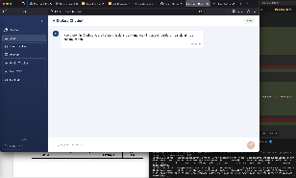 | The site is calling the incorrect depreciated AI model for Gemini.
Typescript code needs to be commented for clarity. | Medium | 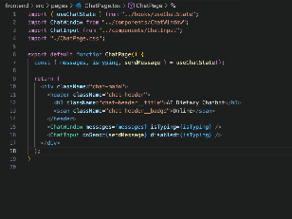 | Adding comments to the code so that others can more easily understand it and debugging would be easier.

